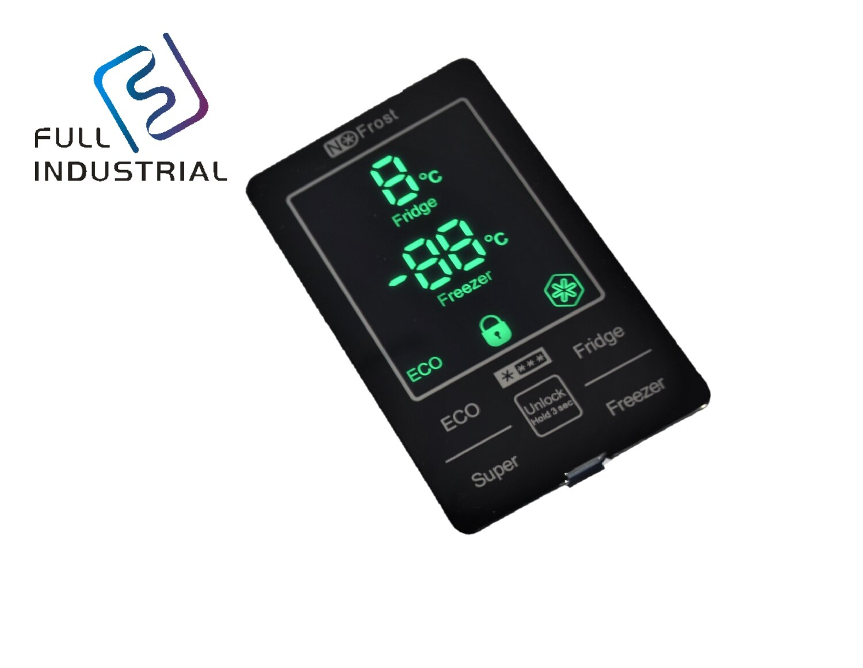
- 7 segment screen display
- IML housing
- Touch button
- Tailor-made is acceptable

